**LAB 5 TASK**

**Q1) Difference between Linux and Unix ?**

|  |  |  |
| --- | --- | --- |
| **Functions Name** | **Linux** | **Unix** |
| **Development and Distribution** | Linux is developed by Open Source development i.e. through sharing and collaboration of code and features through forums etc and it is distributed by various vendors. | Unix systems are divided into various other flavors, mostly developed by AT&T as well as various commercial vendors and non-profit organizations. |
| **User** | Everyone. From home users to developers and computer enthusiasts alike. | Unix operating systems were developed mainly for mainframes, servers and workstations except OSX, Which is designed for everyone. The Unix environment and the client-server program model were essential elements in the development of the Internet |
| **Usage** | Linux can be installed on a wide variety of computer hardware, ranging from mobile phones, tablet computers and [video game consoles](http://www.diffen.com/difference/PS4_vs_Wii_U), to mainframes and supercomputers. | The UNIX operating system is used in internet servers, workstations & PCs. Backbone of the majority of finance infastructure and many 24x365 high availability solutions. |
| **Text mode interface** | BASH (Bourne Again SHell) is the Linux default shell. It can support multiple command interpreters. | Originally the Bourne Shell. Now it's compatible with many others including BASH, Korn & C. |
| **GUI** | Linux typically provides two GUIs, [KDE and Gnome](http://www.diffen.com/difference/GNOME_vs_KDE). But there are millions of alternatives such as LXDE, Xfce, Unity, Mate, twm, ect. | Initially Unix was a command based OS, but later a GUI was created called Common Desktop Environment. Most distributions now ship with Gnome |
| **Security** | Linux has had about 60-100 viruses listed till date. None of them actively spreading nowadays. | A rough estimate of UNIX viruses is between 85 -120 viruses reported till date. |
| **Architectures** | Originally developed for Intel's x86 hardware, ports available for over two dozen CPU types including ARM | In 1969, it was developed by a group of AT&T employees at Bell Labs and Dennis Ritchie. It was written in “C” language and was designed to be a portable, multi-tasking and multi-user system in a time-sharing configuration. |
| **Manufacturer** | Linux kernel is developed by the community. Linus Torvalds oversees things. | Three bigest distributions are Solaris (Oracle), AIX (IBM) & HP-UX Hewlett Packard. And Apple Makes OSX, an unix based os. |
| **Inception** | Inspired by MINIX (a Unix-like system) and eventually after adding many features of GUI, Drivers etc, Linus Torvalds developed the framework of the OS that became LINUX in 1992. The LINUX kernel was released on 17th September, 1991 | In 1969, it was developed by a group of AT&T employees at Bell Labs and Dennis Ritchie. It was written in “C” language and was designed to be a portable, multi-tasking and multi-user system in a time-sharing configuration. |

**Q2) How do I create virtual machine?**

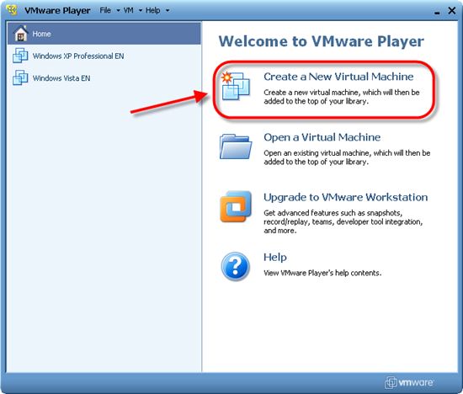

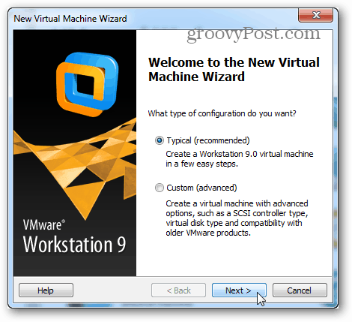

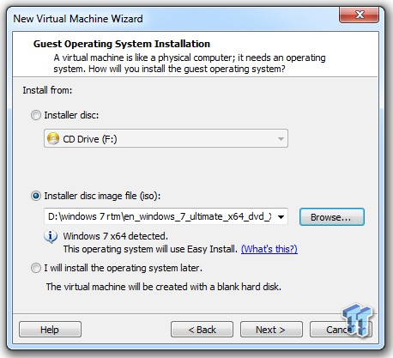

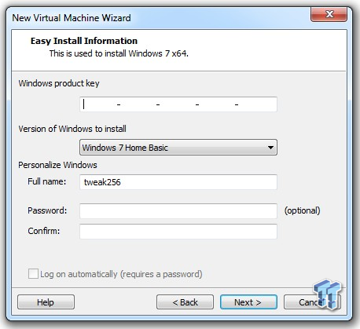

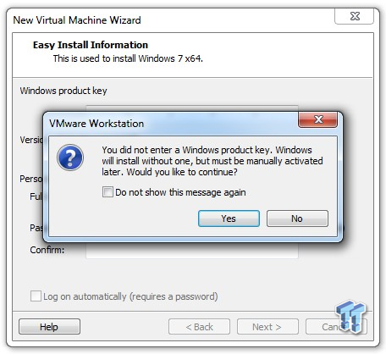

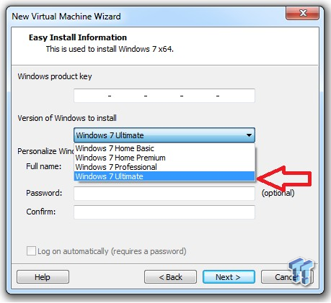

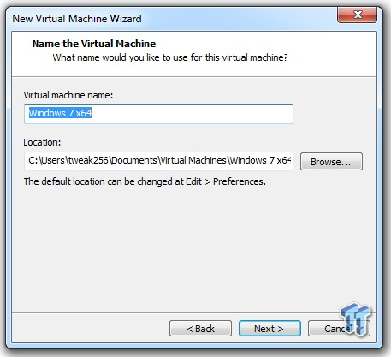

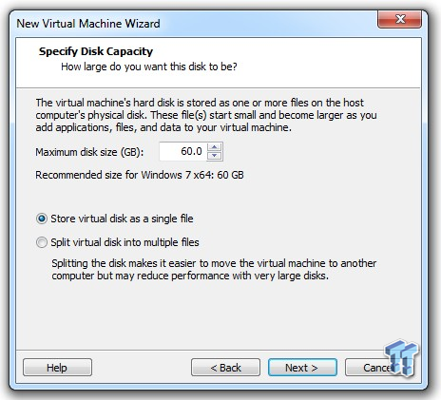

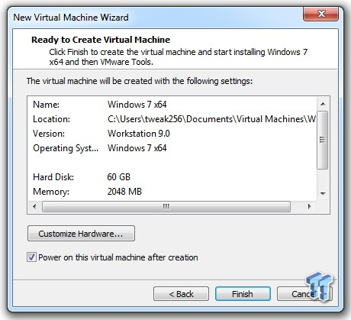

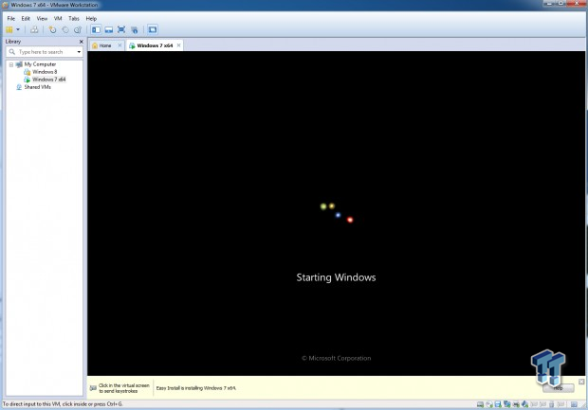

**Q3) Write the advantages and disadvantages of VM?**

**Benefits of Virtual Machine Hosting**

**Familiar Interfaces** – Virtual environments are built to mimic physical ones, so you should never have any idea that you’re running on a virtual machine. Virtual networks include virtual NICs, virtual switches and so on. Other than being able to physically move a server, you’ll receive similar experience and performance on a virtual network that you would with physical servers.

**High Availability** – By distributing load across virtualized machines, virtual hosts are able to ensure high availability of applications and data. Even if one server fails, another virtual machine can be spun up with minimal downtime or data loss.

**Scalability** – Virtualized machines allow scalability on demand without adding physical resources, and they can be expanded much easier than in a physical machine. Adding additional RAM to a virtual machine can be done in a few minutes, while it can be up to a day’s work for a physical machine.

**Backup with Fast Recovery** – Virtualization and cloud computing offer powerful solutions for data backup and recovery. Even if hardware should fail, virtual machines can instantaneously and accurately migrate data to working hardware with little or no downtime.

**Easy Cloning –**Cloning a virtual machine takes just a few clicks and a matter of seconds, whereas cloning a physical machine can be a serious undertaking.

## ****Challenges of Virtual Machine Hosting****

Of course, no technology is without its challenges. Virtualization has a number of advantages over physical machine hosting, but there are some challenges you should be aware of when choosing a virtual hosting company.

**Security** – If you’re moving applications from physical servers to a public cloud, there are a number of security risks since your cloud servers will be hosted on virtual machines in a shared infrastructure. Virtual hypervisors are easier to harden against attack than an operating system, but they are still complex systems that offer a new target for attack, especially in a public cloud. Data pipe offers an ultra-secure cloud environment that is closely monitored to ensure security.

**Potential Downtime** – While it’s unlikely that your virtual resources will all fail at once, it can be more difficult to reboot virtual machines in the event of a catastrophic hardware failure. Virtual machines can power on and off just as easily as a physical machine, but a VM coming online from a host crash will need to wait for their physical infrastructure to boot, plus the time it takes for your virtual machines to boot. The additional downtime may not be outrageous, but it can add up.

**Oversubscription** – Almost all modern cloud environments are built on an oversubscription model, so it is possible to oversubscribe your virtual machines on physical hardware. Essentially, if you have 5 VMs using 2GB RAM running on a physical machine with 8GB RAM, you’ve oversubscribed that hardware. Luckily, oversubscription does not mean over-capacity. Avoiding oversubscription on your virtual machines requires attention to resource allocation to ensure you’re properly utilizing your virtual resources when they’re needed.